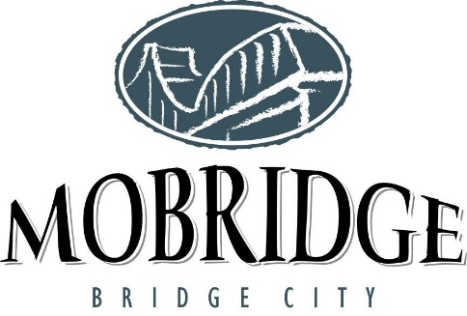

Mobridge Chamber "Denny Palmer Memorial" Fishing Tournament
Rules, Participation Agreement and Release of Liability
Saturday, June 8, 2024 (rules meeting June 7th @ Scherr Howe Event Center

- Eligibility: Entries must be completed, signed, and returned along with entry fee of $300 per two (or three) person team, Entry Fee will go up to $350 after May 24th. Must have a valid SD fishing license and be 18 years of age, unless accompanied by parent or guardian. All entries will be assigned team numbers in the order registrations forms are received
- Fish Limits: State regulations for amount: Can weigh 6 fish (2 fish 20” & over and 4 under). Fish must be 14" minimum.
- Boundaries: Lake Oahe - North to State Line; the entire Moreau River (to it's South point); and South to Hwy 212 bridge.
- Fishing Hours: Saturday, June 8th starting at 7:45am. Launch flighting every 15 minutes is likely. All teams will be given 7 hours of fishing after their flight.
- Safety: All boats must follow U.S. Coast Guard and South Dakota Game, Fish and Parks Regulations. Boats will leave "Indian Creek Recreation Area" bay in a single file by team number. A tournament boat will start each flight, no boat shall leave until signaled by the tournament boat.
- Sportsmanship: Contestants are expected to practice good sportsmanship, be courteous and be safety conscious always. Please respect other fishermen whether they are in the tournament or not.
- Tournament Headquarters: Will be at Scherr Howe Event Center, Mobridge, SD. Anglers must be off the water by 4 pm the day of the rules meeting.
- River Headquarters: Will be at "Indian Creek Recreation Area". Boat Inspection and Launch will take place at River Headquarters.
- Scoring: Prizes will be awarded to teams based on the total weight caught during the day of the tournament. Teams will weigh a total of 6 walleye or saugers, of which two may be 20 inches or over. Remember, no culling, or sorting will be allowed. This is a state law. Teams will be able to keep or donate their fish. If kept, anglers are responsible for cleaning, packaging, storing, and transportation per state regulations.
- Weigh-In: You can start weighing in as early as 2:30 pm at the backdoor of Scherr Howe Event Center
- If you are late to return, you are disqualified. Any team not returning on or before their assigned return time will be disqualified.
- Bad Weather – if inclement weather, there will be no refunds on entry fees. The fishing tournament will be held on Sunday. If the weather is still inclement on Sunday, prizes for places will be drawn.
- Teams must register at https://mobridge.formstack.com/forms/denny_palmer by 5:00 pm on June 7th
- Tournament fishermen cannot fish with non-tournament fishermen.
- You may only use a standardized hook-and-line system with artificial bait or live bait to include: (less than 12 dozen) fathead minnows, creek chubs, white suckers, and golden shiners. If using more than 12 dozen or any other bait, you must have an importation permit from the SD GF&P. No Spearing or Snagging Fish. Each contestant may fish with two rods each. Spare rods, reels, and tackle may be carried in your boat.
- The “Golden Rule” will be used as the official tournament ruler. Fish will be measured on both sides and tails will be pinched. Any mangled, mashed, or mauled fish will be weighed at the discretion of the weigh-in official and tournament coordinator. All decisions of the measure master, weigh master, and tournament coordinator are final. If you want to confirm your ruler the official tournament ruler will be available at the Rules Meeting.
Participation Agreement: By participating, I understand this is a professional sporting event governed by the rules that have been established by tournament organizers. I acknowledge I have received a copy of these rules, read them, and understand them. In addition to terms of entry and competition, these rules relate to the safety of all participants as well as the fair sporting conduct of this event. The Chamber Executive Director / Tourism Committee shall act as the referee in all disputes and his/her decision based on his/her interpretation of the rules will be final and without legal appeal. I understand there are never refunds for tournament entry fees. The Mobridge Chamber of Commerce (MCC) reserves the right to use any photograph / video taken at any event sponsored by MCC without the expressed written permission of those included within the photograph / video. MCC may use the photograph / video in publication or other media material produced, used or contracted by MCC including but not limited to brochures, invitations, books, newspapers, magazines, television, websites, etc. By participating in an MCC event or by failing to notify MCC in writing, your desire to not have your photography used by MCC, you are agreeing to release, defend, hold harmless and indemnify MCC from and all claims involving the use of your picture or likeness.

Release of Liability. Warning: under South Dakota law, no fishing tournament sponsor or fishing professional is liable for an injury to, or the death of, a participant resulting from the inherent risks of fishing, pursuant to South Dakota Codified Laws 20-9-47 to 20-9-51.

