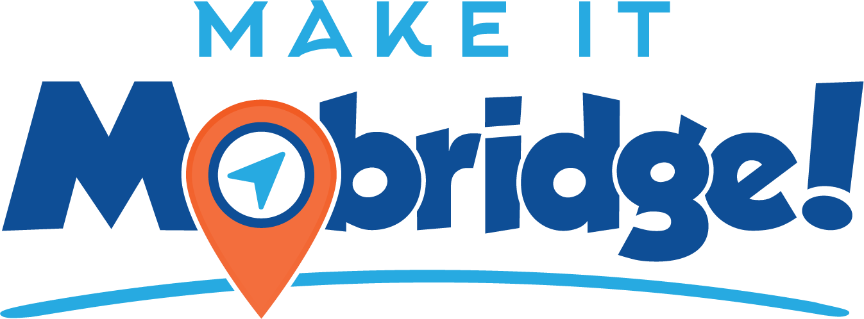
Mobridge Area Chamber of Commerce
212 N Main Street, Mobridge, SD 57601
chamber@mobridge.org | 605.845.2500 | mobridge.org
2025 Membership Form

Mobridge is a busy town with a population of nearly 3,400 and over 150 local businesses. We are also a vibrant tourist destination who welcomes thousands of anglers, hunters, and travelers each year. The Chamber of Commerce plays a vital role to our citizens and visitors. We are their directory for business referrals, sites to see, places to stay, restaurants to eat at, where to shop, entertainment recommendations, and more! Join the Chamber today and let us advocate for you!

BUSINESS _______________________________________________________________________

CONTACT PERSON _______________________________________________________________

PHYSICAL ADDRESS ______________________________________________________________

MAILING ADDRESS _______________________________________________________________

CITY _____________________________ STATE ______________ ZIP CODE ________________

TELEPHONE_____________________________________________________________________

EMAIL___________________________________________________________________________

WEBSITE ADDRESS_______________________________________________________________

- BUSINESS DIRECTORY ONLY $60.00 $_________________
* Business will be in the print and online directory and will receive no other benefits
- ESSENTIAL MEMBERSHIP $300.00 $_________________
- CONNECTOR MEMBERSHIP $600.00 $_________________
- PARTNER MEMBERSHIP $1,000.00 $_________________

Signature: ___________________________________ Date: __________________
* Your Chamber membership is annual (January 1 – December 31).

